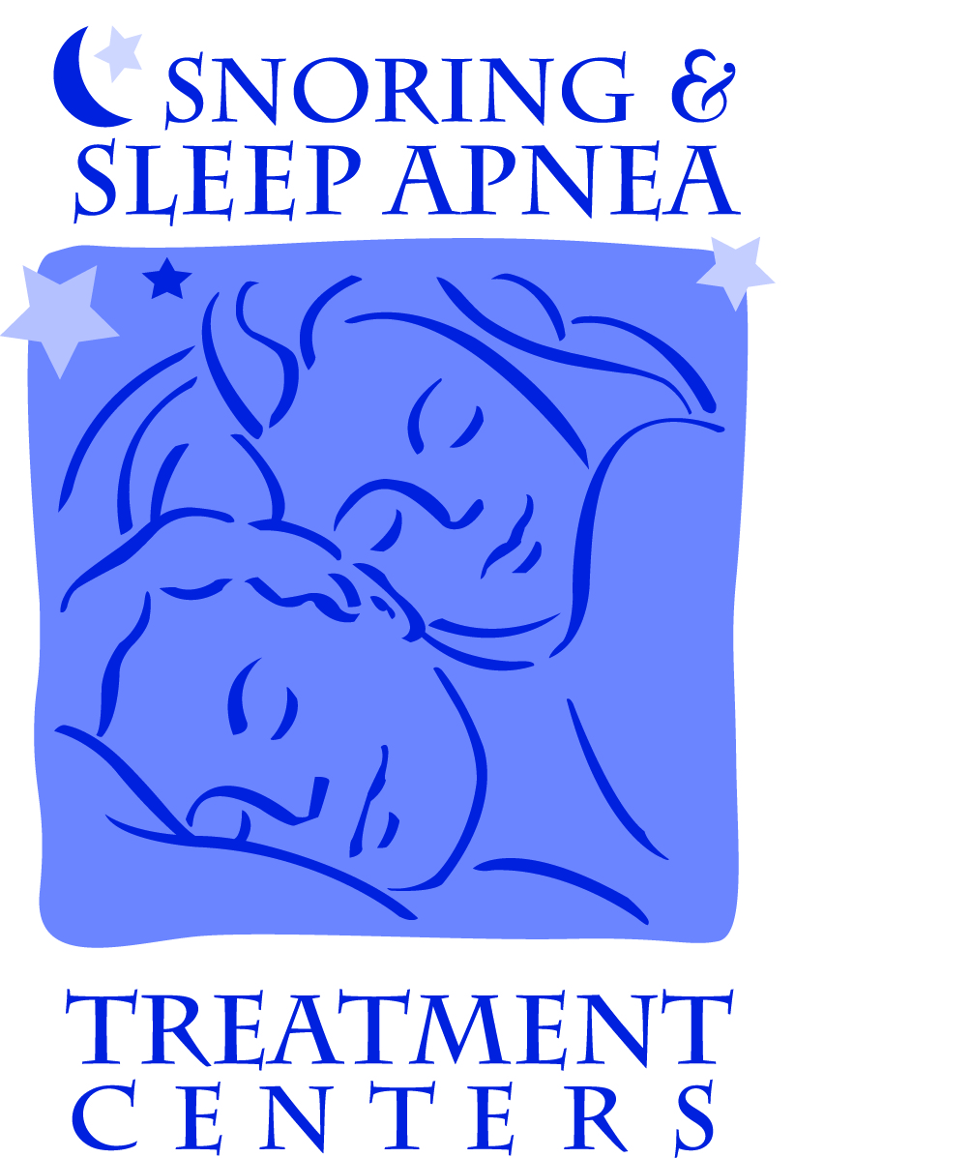
SNORING & SLEEP APNEA TREATMENT CENTERS
NEW PATIENT VISIT

NAME (Last) _______________________ (First) ______________________ Male / Female Date:________________

DOB: _______________

Chief Complaint (Why are you here?)

(How can we help you?)
History of Present Illness:
When did the problem start:
Changes in your condition over past 6 months?:

Other problems related to chief complaint:

Treating doctor reviewed medical questionnaire completed by patient dated ______________.

Additional Notes:

NAME (Last) _____________________________ (First) ____________________________ DOS ___________________

Main Concerns:

Inability to sleep for more than ________ hours interrupted:
Frequency / Duration: every night or _____ times/week
Modifying Factors:
Aggravating factors / Context (what makes it worse):
Alleviating factors (what makes it better):
Associated signs and symptoms (anything else that occurs at the same time):

Inability to fall asleep:
Frequency / Duration: every night or _____ times/week
Modifying Factors:
Aggravating factors / Context (what makes it worse):
Alleviating factors (what makes it better):
Associated signs and symptoms (anything else that occurs at the same time):

Gasping/chocking/stop breathing while sleeping:
Frequency / Duration: every night or _____ times/week _____ times/night
Modifying Factors:
Aggravating factors / Context (what makes it worse):
Alleviating factors (what makes it better):
Associated signs and symptoms (anything else that occurs at the same time):

Fatigued/groggy/tired during day time:
Frequency / Duration: every day or _____ times/week
Modifying Factors:
Aggravating factors / Context (what makes it worse):
Alleviating factors (what makes it better):
Associated signs and symptoms (anything else that occurs at the same time):

Restless legs during sleep:
Frequency / Duration: every night or _____ times/week
Modifying Factors:
Aggravating factors / Context (what makes it worse):
Alleviating factors (what makes it better):
Associated signs and symptoms (anything else that occurs at the same time):

Jaw & Facial Pain: Severity: no pain 1 2 3 4 5 6 7 8 9 10 severe pain
Location:
Quality:
Frequency / Duration: on/off daily constant
Modifying Factors:
Aggravating factors / Context (what makes it worse):
Alleviating factors (what makes it better):
Associated signs and symptoms (anything else that occurs at the same time):

Headache: Severity: no pain 1 2 3 4 5 6 7 8 9 10 severe pain
Location:
Quality:
Frequency / Duration: on/off daily constant
Modifying Factors:
Aggravating factors / Context (what makes it worse):
Alleviating factors (what makes it better):
Associated signs and symptoms (anything else that occurs at the same time):

NAME (Last) _________________________ (First) ____________________________ DOS: ___________________
REVIEW OF SYSTEMS
Pertinent positive findings relevant to the treatment of the patient’s current condition are noted below.
The remaining systems were reviewed and are negative. Dr’s Initials: ___________
1. | Constitution: Weight change Loss of appetite Blurred Vision Trouble sleeping
2. | Eyes: Visual changes Blurred vision Double vision Pain Light sensitivity Drainage Redness  Glaucoma
3. | Ears: Hearing problems Pain Drainage Ringing Clicking/Popping Dizziness Tinnitus Vertigo
 | Nose: Change in sense of smell Congestion Nose bleeds Facial Pain Nasal drainage Sinus Pain
Mouth & Throat: Voice changes Teeth pain Bleeding swollen gums Change in sense of taste Sore throat
Difficulty swallowing Jaw Clicking/Popping Dental problems Dentures Laryngeal problems
4. | Skin: Rashes Itching/change in texture Change in size, color, discharge of mole Birthmarks  Change in skin, hair or nails
5. | CV: Chest pain Chest palpitations Difficulty breathing while lying down Swelling in legs or feet  High blood pressure Congestive heart failure History of Heart attack / heart disease / coronary artery disease  Heart murmur Valve replacement Stent Heart valve replacement Rheumatic Fever
6. | GI: Nausea Reflux Loss of appetite Difficulty swallowing Ulcers
7. | Genitourinary: Pregnant - Trimester 1 2 3 Birth control Hysterectomy Menopause Breast feeding
8. | Resp: Snoring Sleep Apnea PSG done: date: ________ wears C-Pap: restless leg syndrome  Bronchitis Asthma Emphysema Pneumonia Tuberculosis SOB Pain with breathing Cough
9. | Endo: Hx of diabetes thyroid problems Unplanned weight loss/gain Feeling excessively cold/hot  Increase in thirst/urination Abnormal hair growth High Cholesterol Anemia Prolonged bleeding
10. | Musc/Skel: Joint swelling/pain Muscle aches Cramps Headaches Neck pain  Rheumatoid Arthritis Osteoarthritis Psoriatic arthritis Fibromyalgia Lyme’s disease Raynaud’s Disease
11. | Neuro: Problems with coordination/walking/memory/weakness Dizziness/blackout/seizures Tremors  Numbness or tingling Concussion Epilepsy Seizures Traumatic Brain Injury Headaches Slurred speech  Stroke Parkinsonism Multiple sclerosis (MS) Migraines Traumatic brain injury (TBI)
12. | Psych: Feeling of sadness Difficulty sleeping Mood changes Unusual headache Worry Panic
 | Loss of appetite Anger Depression Anxiety Suicidal Thoughts Tension Drug Addiction Counseling
13. | Allergy: Sneezing Itchy/Watery eyes Runny nose Seasonal Latex Food  Medication:
14 | Sleep-related issues: Snoring Sleep Apnea (previously diagnosed) Suspected / Risk for Sleep Apnea  Previous / Current Use of CPAP Previous Surgery Headaches Daytime Sleepiness / Tired  Low Energy Bruxism / Clenching Acid Reflux (GERD) Frequent Cough  Frequent sore throats in AM Feel Depressed Anxiety Mood Swings / Irritable  Hard to Concentrate Other __________________________

The new patient intake form dated ____________ was reviewed, signed and dated by me. The data that I reviewed included the following:
________Review of Systems (ROS)
________Past / Family / Social History (PFSH)
________Health
________Reviewed PSG with patient performed by ______________________________ dated ___________________

NAME (Last) _________________________ (First) ____________________________ DOS___________________

PHYSICAL EXAM

System Normal Abnormal System Normal Abnormal
Constitutional | - General appearance | N | ABN | Neuro | - Cranial nerves (2 - 12) | N | ABN
 | - Height:______ Weight:______ BMI: _______ |  |  |  | - Deep tendon reflexes | N | ABN
 | - Neck Circum. _______ Abd Circum: _______ |  |  |  | - Sensation | N | ABN
 | - BP: ______/______ HR: _______/min |  |  |  | - Coordination
 | - Resp: _______/min Pulse Ox: _______ % |  |  | Skin | - Inspect skin subcutaneous tissue | N | ABN
Ear | - Inspect lips, teeth, gums | N | ABN |  | - Palpate skin subcutaneous tissue | N | ABN
Nose | - Oropharnyx (mucosa, salivary glands,
Mouth | hard/soft palate, tongue, pharynx) | N | ABN | MS | - Inspect head & face | N | ABN
Throat | - External ears and nose | N | ABN | Head & Neck | - Palpate face, sinuses | N | ABN
 | - Inspect auditory canal and TM’s | N | ABN |  | - Examine salivary glands | N | ABN
Eyes | - Inspect conjunctiva, lids | N | ABN |  | - Exam of Thyroid | N | ABN
 | - Examine pupils and irises | N | ABN |  | - Neck (masses, tracheal position,
 |  |  |  |  | symmetry, crepitus, overall appearance | N | ABN
Psych | - Alert, oriented to person, place, time | N | ABN
 | - Mood and affect | N | ABN
 | - Recent and remote memory | N | ABN
 | - Description of patient’s judgment/insight | N | ABN

Abnormal Notes: ___________________________________________________________________________________________________________

___________________________________________________________________________________________________________________________

___________________________________________________________________________________________________________________________

Exam relevance to chief complaint: ___________________________________________________________________________________________________________________________

___________________________________________________________________________________________________________________________

___________________________________________________________________________________________________________________________

NAME (Last) _________________________ (First) ____________________________ DOS___________________

EXAM DETAIL:

TMJ/TMD: Yes No
Previous treatment: _____ Splint _____ Physical Therapy _____ Medication ____ Surgery

Range of Motion: Opening ______ mm Protrusion _______ mm Deviation or Deflection Lateral Movement to the: Right _______ mm Left _______ mm

TMJ: ROM _____ mm R: reciprocal click _____ L: reciprocal click _____
Exam relevance to chief complaint:

opening click _____ opening click _____
crepitus _____ crepitus _____
popping _____ popping _____

PTP: None_____ R: masseters _____ L: Masseters _____
Temporalis _____ Temporalis _____
TMJ _____ TMJ _____
Cervical _____ Cervical _____

Palatal vault form: ___ normal ___ shallow ___deep

Maxillary arch width: ___ normal ___ wide ___ narrow
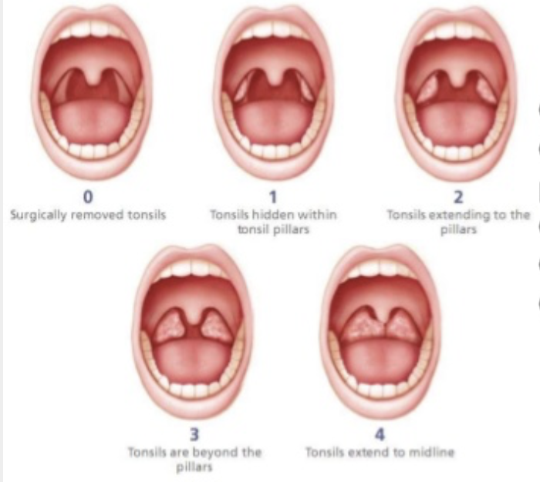
Tonsils grade:

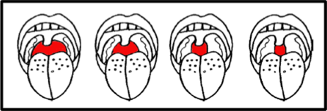
Pharyngeal grade: I ___ II ___ III ___ IV ___

(Sampsoon-Young Pharyngeal Grade)

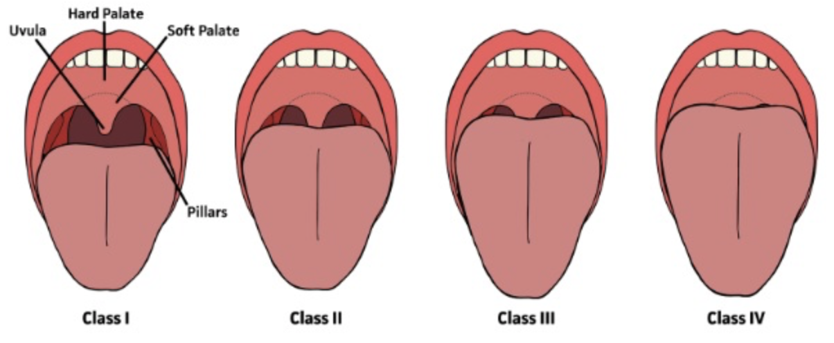
Soft palate: I ___ II ___ III ___ IV___

(Modified Mallampati Classification)

NAME (Last) _________________________ (First) ____________________________ DOS___________________

Dentition/Oral Evaluation:
Occlusion: ___ Class I ___ Class I Div 2 ___ Class II ___ Class II Div 2 ___ Class III
Malocclusion: Yes No Other ________________________
Crossbite ___________________________ Open bite________________________________
Tooth wear: Anterior: enamel _____ dentin _____
Posterior: enamel _____ dentin _____
Tooth Sensitivity: Yes No

Periodontal Status: grossly intact - Yes No Other ____________________________

Missing teeth: 3rds only ____; Upper ____ Lower ____ bicuspids; Others: _______________

Tongue: ___ Appears Large ___ Coated ____ Scalloped ___ Fissured ___ Tongue tied ___Midline Groove
Lips: ___ Poor/Strained Lip Seal ___ Lips Dry/Chapped ___ No Lip Seal ___ Relaxed/Comfortable Lip Seal
Nasal Dilation (Cottle test): ___ Improved Nasal Breathing ___ No Change
Additional Notes:

STOP-BANG QUESTIONNAIRE
STOP
Do you SNORE loudly (louder than talking or loud enough to be heard through closed doors(? | Yes | No
Do you often feel TIRED, fatigued, or sleepy during daytime? | Yes | No
Has Anyone OBSERVED you stop breathing during your sleep? | Yes | No
Do you have or are you being treated for high blood PRESSURE? | Yes | No

BANG
BMI more than 35 kg/m2? | Yes | No
AGE over 50 years old? | Yes | No
NECK circumference > 16 inches (40 cm)? | Yes | No
GENDER: Male? | Yes | No

TOTAL SCORE

Risk: Yes 5 - 8 High
Yes 3 - 4 Intermediate
Yes 0 - 2 Low

NAME (Last) _________________________ (First) ____________________________ DOS___________________

ASSESSMENT AND PLAN FOR TREATMENT

Based upon the findings in the history, exam and sleep study, the following areas are relevant to the chief complaint:

Diagnosis from PSG: No PSG, Differential dx: TMJ diff dx:
___ Snoring (R06.83) ___ Snoring (R06.83) ___ TMJ disc disorder (M26.63_)
___ Mild sleep apnea (G47.33) ___ Sleep Apnea (G47.30) ___ TMJ arthralgia (M26.62_)
___ Moderate sleep apnea (G47.33) ___ Other SDB (G47.80) ___ MFPD (M79.10 )
___ Severe sleep apnea (G47.33) ___ No sleep disorder ___ Fibromyalgia (M79.70)
___ UARS (G47.14) ___ UARS (G47 .14) ___ Disc disorder w/o reduction ___ RLS (G25.81) ___ Sleep r/bruxism (G47.63) ___ Disc disorder w/ reduction
___ PLMS (G47.61) ___ Sleep r/mvmt d/o (G47.60) ___ Osteoarthritis (M26.69)
Orders:
___ Impressions for insert/fit of oral appliance

Oral Appliance: Lab:
___ Silent Night ___ DSG Lab Michigan
___ TAP III ___ Respire New York
___ TAP Elite ___ Airway Labs Dallas
___ Somnomed ___ Somnomed Dallas
___ PM Positioner ___ Strong Dental Michigan
___ SUAD ___ Zepeda Lab Illinois
___ Herbst ___ Lord’s Dental Wisconsin
___ Custom mask / appliance ___ DPS Iowa ___ EMA ___ Glidewell
___ Respire Pink ___ Other _____________________
___ Respire Blue
___ Respire Green

Radiographs:
___ CBCT
___ TMJ imaging (CT / MRI)
___ Panograph
___ Airway imaging (___ with appliance / ___ without appliance)

Other ________________________

Referrals: Medications: _________________________
___ PSG or HM after titration
___ TMD Eval Other: __________________________________
___ Physician ____________________ ________________________________________
___ Dentist ______________________ ________________________________________
___ ENT ________________________
___ Pulmonology _________________
___ Neurology ___________________
___ Other ________________________

Doctor’s Notes:
____________________________________________________________________________________________________________________________________________________________________________________________________________________________________________________________________________________________________________________________________________________________________________________________________________________________________________________________

Disp: __________________________________ Signature: ______________________________________________________________

